Experiment 6

Draw the DFD to be considered while codding the individual processes or functions.

0 level DFD

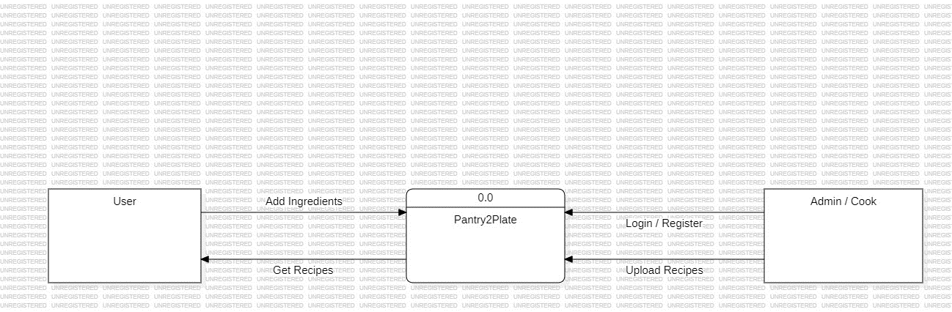

1 level DFD

